

BSc (Hons) in Computer Science via GDSE

Module Code ITS1066

Professional Software Project in IT

**Restaurant Management System**

**STUDENT NAME- Theekshana De Silva**

**STUDENT ID - 200319200871**

**BATCH NO - GDSE66**

**SUBMISSION DATE(24/03/2023)**

**Content**

| **No** | **Title** | **Page** |
| --- | --- | --- |
| 1.0 | Introduction to business | 4 |
| 2.0 | Overview of the proposed solution | 6 |
| 3.0 | Advantages of the solution | 7 |
| 4.0 | Use case diagram | 9 |
| 5.0 | Entity relationship diagram (ERD) | 10 |

**List of Figures**

**No**

**Title**

**Page**

Figure 1.1

Employee Hierarchy

12

**List of Abbreviation**

IJSE

IT

SE

QAE

SD

BCS

HR

- Institute of Java & Software Engineering

- Information Technology

- Software Engineer

- Quality Assurance Engineer

- Software Developer

- British Computer Society

- Human Resource

**Introduction to business**

**Overview:**

Dhanuja Cafe is a restaurant located in the Hapugala area in Galle. The primary customers are the students of the Hapugala Engineering Faculty, and it has been in operation for 20 years. Initially starting as a tea shop, it has now evolved into a popular restaurant, more commonly known as "Bata Kade," due to the large bamboo tree in front of the shop. The restaurant currently employs around 14 permanent staff, and it faces the challenge of managing long queues during peak hours, particularly after the end of university lectures.

**Business Objectives:**

The primary objective of Dhanuja Cafe is to provide quality food and beverages to the customers and maintain a high level of customer satisfaction. As the business has been in operation for a long time, it has developed a loyal customer base, and it aims to retain them while also attracting new customers. To achieve this objective, the cafe aims to improve its processes and procedures to ensure that customers are served quickly and efficiently.

**Market Analysis:**

The Hapugala area has a high concentration of university students, and as a result, there is a high demand for food and beverages in the area. Dhanuja Cafe has been able to leverage this demand and establish itself as a popular destination for the students. However, there is still significant room for growth in the market, and the cafe aims to capitalize on this opportunity by improving its services and expanding its customer base.

**Products and Services:**

Dhanuja Cafe offers a range of products and services, including cooked food, drinks, desserts, biscuits, chocolates, toffees, and soaps. The cafe has a reputation for providing high-quality food, and it aims to maintain this reputation by sourcing its ingredients from reliable suppliers. Additionally, the cafe aims to improve its product offering by introducing new items that are popular with its target customers.

**Operations:**

One of the primary challenges that Dhanuja Cafe faces is managing the long queues that form during peak hours. To address this challenge, the cafe aims to improve its processes and procedures to ensure that customers are served quickly and efficiently. The current process involves the customer queuing up near the shop entrance door and then going to the cashier area to place an order. After paying, they then have to wait for the food to be served by the waiters. The cafe aims to streamline this process by introducing an online ordering system that allows customers to place orders in advance and avoid queuing up.

**Management:**

The cafe currently employs around 14 permanent staff, and managing them is essential to the smooth running of the business. To ensure that employees are motivated and productive, the cafe aims to implement an employee management system that includes performance evaluations, training, and development programs. Additionally, the cafe aims to maintain good relationships with its suppliers and keep track of daily sales and store reports to monitor the business's performance.

Conclusion:

In summary, Dhanuja Cafe is a well-established restaurant that aims to maintain its reputation for providing high-quality food and beverages. The cafe faces the challenge of managing long queues during peak hours, and it aims to address this challenge by improving its processes and procedures. Additionally, the cafe aims to expand its customer base and introduce new products and services that are popular with its target customers. With a robust management system in place, the cafe aims to maintain its position as a leading provider of food and beverages in the Hapugala area.

**Overview of the proposed solution**

Managing customer traffic and improving the ordering process is a critical aspect of running a successful restaurant. In response to the challenges faced by Dhanuja Cafe, I propose the following solution.

Firstly, customers will place their orders with the cashier, who will enter the order details into the system. The cashier will then receive payment from the customer and provide a bill. Simultaneously, the order will be displayed on a screen in the waiter section, allowing the waitstaff to prepare the order promptly.

Once the order has been prepared, the cashier or waiter will mark it as complete in the system. The customer will be notified via a display that their order is ready for pickup.

The proposed solution also involves keeping detailed records of orders, items, suppliers, and daily summaries. These details will be saved in a database for easy access and analysis.

Implementing this solution will help to streamline the ordering process, reduce wait times, and improve customer satisfaction. With a more efficient system in place, Dhanuja Cafe will be better equipped to handle high traffic volumes and maintain a high level of service quality.

Additionally, the proposed solution includes implementing an employee management system that includes performance evaluations, training, and development programs. This will help to ensure that the staff is well-trained and motivated, resulting in a more productive workforce and a better customer experience.

In conclusion, the proposed solution offers a comprehensive and effective way to manage the customer traffic and improve the overall efficiency of Dhanuja Cafe. By implementing this solution, the cafe can enhance its reputation, attract more customers, and achieve long-term success in the highly competitive restaurant industry.

**Advantages of the solution**

1. **Improved customer satisfaction:**

With a more efficient and organized ordering process, customers are likely to have a better experience at Dhanuja Cafe. They will have shorter wait times, which can help to increase customer loyalty and retention. Additionally, the proposed solution includes a customer display that shows the status of their order, which can help to improve communication and transparency between the staff and customers.

1. **Increased efficiency:**

The proposed solution involves using a system to manage orders, which can help to speed up the ordering process and reduce errors. This can result in a more efficient operation and reduce costs associated with food wastage. Furthermore, the system can help to optimize inventory management, allowing the business to keep track of its supplies and avoid overstocking or stockouts.

1. **Enhanced data management:**

The proposed solution includes saving order details, item details, supplier details, and daily summaries in a database. This will help the business to better manage its inventory, track sales trends, and make informed decisions about menu items and pricing. The system can also generate reports that provide insights into the performance of the business, which can be used to identify areas for improvement.

1. **Employee management:**

The proposed solution includes implementing an employee management system that includes performance evaluations, training, and development programs. This will help to ensure that the staff is well-trained and motivated, resulting in a more productive workforce and a better customer experience. Furthermore, the system can help to identify and address performance issues, which can lead to improved employee retention and job satisfaction.

1. **Competitive advantage:**

By implementing the proposed solution, Dhanuja Cafe can enhance its reputation, attract more customers, and achieve long-term success in the highly competitive restaurant industry. It can also differentiate itself from competitors by offering a more efficient and customer-centric service. Furthermore, the system can help to optimize pricing strategies, allowing the business to offer competitive prices while maintaining profitability.

The proposed solution has several advantages for Dhanuja Cafe, including improved customer satisfaction, increased efficiency, enhanced data management, better employee management, and a competitive advantage in the restaurant industry. With a more efficient and organized ordering process, customers are likely to have a better experience at the restaurant. The proposed system can help to speed up the ordering process, reduce errors, and optimize inventory management, resulting in a more efficient operation and reduced costs associated with food wastage. Additionally, the proposed solution includes a database that can help the business to better manage its inventory, track sales trends, and make informed decisions about menu items and pricing. The employee management system included in the proposal can help to ensure that the staff is well-trained and motivated, resulting in a more productive workforce and a better customer experience. Finally, the proposed solution can help Dhanuja Cafe to differentiate itself from competitors by offering a more efficient and customer-centric service, while optimizing pricing strategies to maintain profitability.

**Use case diagram**

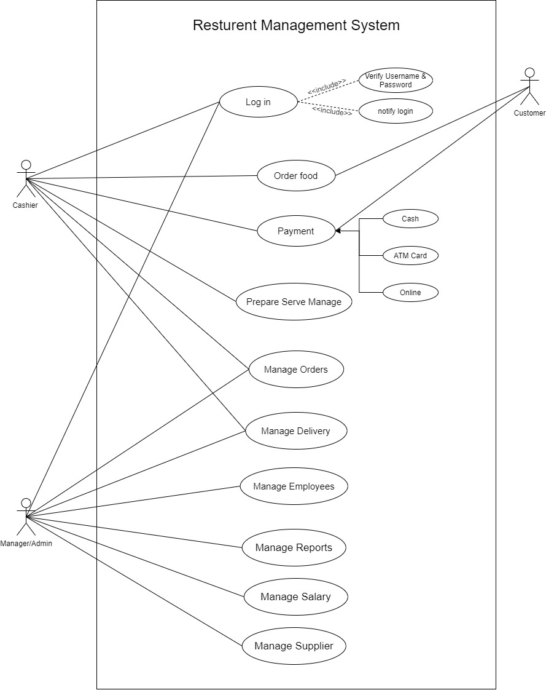

**Entity relationship diagram (ERD)**

